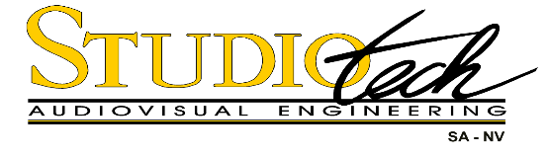

STUDIOTECH's main business is engineering, distribution/sales, installation and after-sales servicing of broadcast and professional audio/video equipment. The company also designs and installs turnkey projects such as recording/mixing studios, editing suites and mobile OB units.

Vacancy for Electrician

Studiotech Belgium is recruiting a hands-on, low voltage, Electrical Technician based in our Brussels office, with a real passion for basic electronics and electricity, and the ability to travel within Europe or overseas as required.

Experience:

- Applicants for this post should have a degree in industrial electricity
- Minimum two years’ hands-on experience in industrial environment
- French speaking, intermediate knowledge of Dutch and/or English is an advantage

Responsibilities:

- Install and repair electrical and control systems
- Ability to design and draw schematics is a plus

Profile:

- Proactive and motivated
- Flexible, able to work alone or in a team
- Able to multi-task and transition between concurrent projects
- Available to travel within Europe or overseas

Offer:

- Pleasant, dynamic working environment in an open-minded company culture
- Attractive remuneration package commensurate with skills and experience

If your experience matches our challenges, please send your CV with a covering letter stating salary expectations to jobs@studiotech.be

Or write to: Human Resources, Studiotech sa-nv,

Houtweg 7, 1130 Brussels, Belgium

